**Physical Location Factors in Voter Participation and Behavior: Undervoting in the 2018 Board of Education Contests in Wake County, North Carolina**

**(The Presentation)**



**Johnny Crawford**

**May 18, 2020**



**“Just because you do not take an interest in politics doesn't mean politics won't take an interest in you.”**

**– Pericles**

**Let’s say you are going in to your local polling place to vote?**

**What would cause you to vote for a particular candidate for**

**your local school board?**

**Their concern for students?**

**Their policy ideas?**

**Their ability to convey themselves?**

**How about the building you are voting in?**

**This presentation (and the companion report and notebook) deal**

**with how places…**

**...where votes are held…**

**...to the type of venues in your neighborhood…**

**...may decide how you vote.**

**Specifically, one behavior… and one type of local race…**

**The behavior is undervoting… or leaving some positions**

**blank that you are able to vote for.**

**Thus… is there any relationship to the place that voting is held**

**(or the mix of local venues) to whether a person is more likely to**

**undervote for Board of Education.**

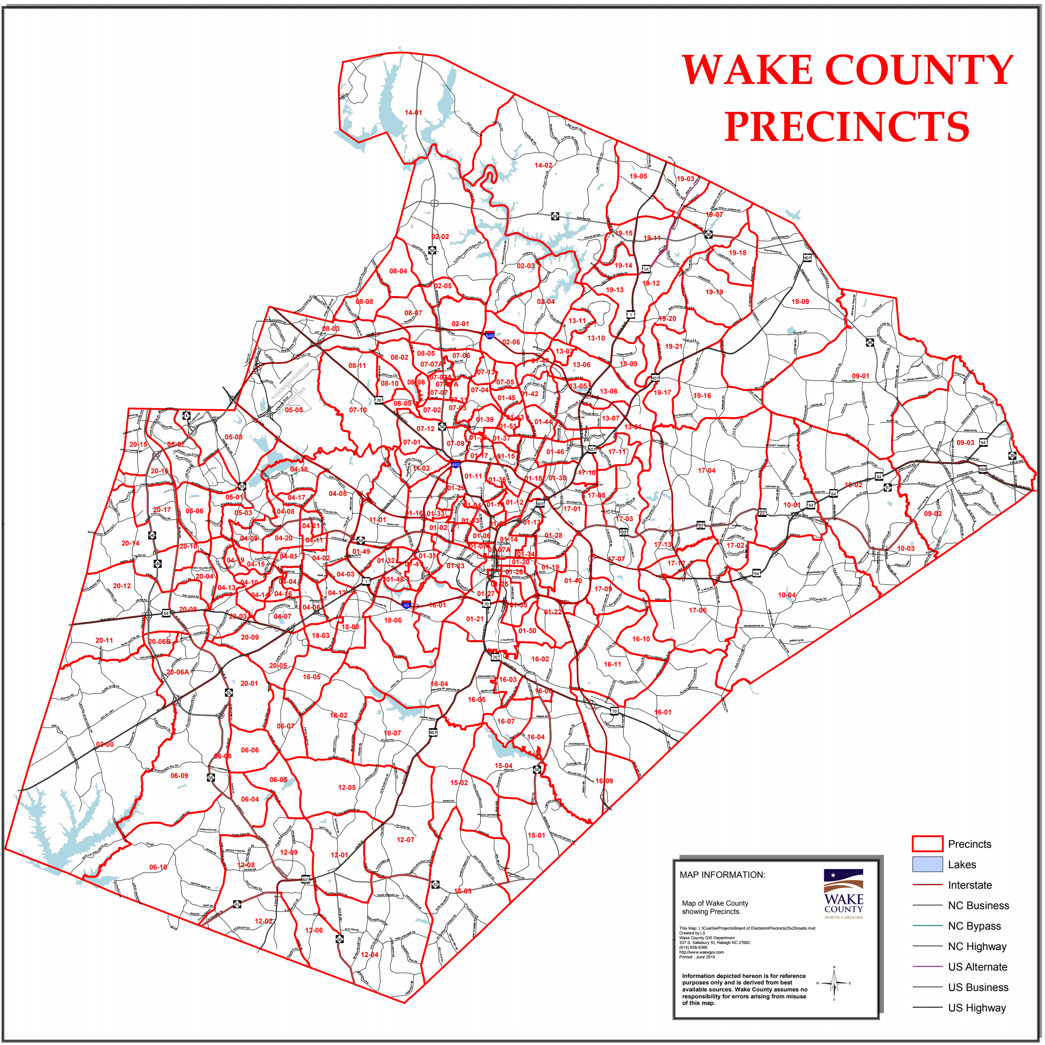**This study used real precinct data and vote results furnished by Wake County (NC)**

**Board of Elections and**

**supplemented with data**

**obtained via the Foursquare**

**API to look at undervoting in**

**the 2018 Midterm election for**

**Board of Education races in**

**Wake County, North Carolina –**

**home of the City of Raleigh,**

**capital of North Carolina.**

Using CSV files, KML location files, the location of all precincts and the type of

building or facilty was determined.

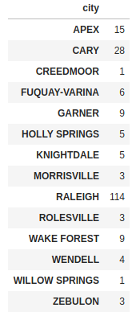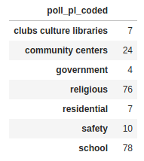

General statistics were obtained about vote casts and a percentage

value for “undervotes” per precinct were determined.

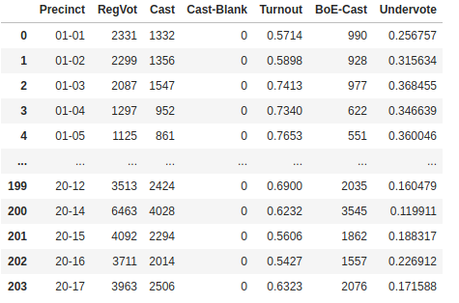

Of everyone who received and completed a ballot, an average of 28% of ballots did

not record a vote for a Board of Education candidate.

Some precincts were as high as 48%!!!

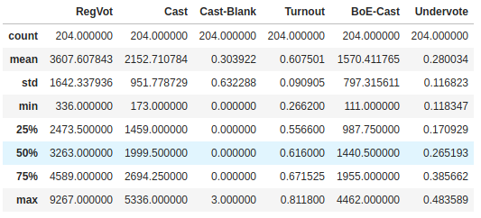

Descriptive statistics showed only weak correlations for votes regardless of venue.

The strongest correlation (an inverse one) was for undervoting in community centers.

The weakest correlation was for ballots cast in schools.



Foursquare data also presented a weak link between local venues and undervoting.

The strongest of the weak correlations (less likely to undervote) was seen when parks

and shopping malls were venues nearby to polling places.

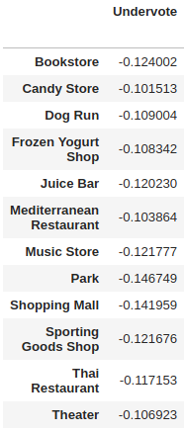Other venues are as follows…

Some venues near to polling locations made undervoting for Board of Education

candidates more likely.

These included Toy/Game Stores. Many of the other high venues that correlated

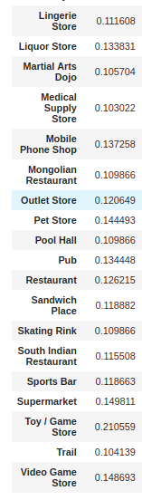with high undervoting were entertainment facilities.

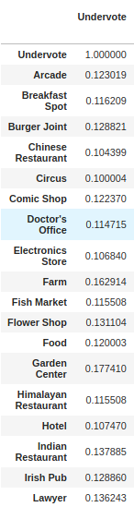

In conclusion…

While the relationships were weak, this is a start for further research…

...for outreach…

…for activism…

...understanding...

...for better government.